Credit Risk and Control in COVID-19 era, research for Australia and New Zealand Banking Group

KARTHIKEYA NALLURI

Table of Contents

Executive Summary: 3

Analysis of credit risk exposures 3

Credit risk 3

Measurement of credit risk 4

Some the techniques for quantifying the credit risk are given below: 4

Risk control 6

Impact of COVID-19 on the credit risk of ANZ bank: 8

Collectively assessed credit impairment charge: 10

Individually assessed credit impairment charge: 10

Has the bank applied new strategy to mitigate possible credit risks? 10

Customer measure: 11

Personal customer support 11

Measures ANZ bank has taken to reduce credit risk and their impact. 12

Recommendations for further credit risk reduction. 13

Conclusion 14

Reference list 15

Appendix 18

# Executive Summary:

The report mainly discusses about credit risk, credit risk measurement, ANZ Bank, how ANZ bank controls credit risk. Credit risk is essential variable which exists in the financial institutional structure. The performance of the institution can be affected due to variances in credit risk. The Coronavirus pandemic has increased trouble in bank’s usual credit risk management and uncertainty. Bank has no guarantee how customers would repay their credits. It directly hit the bank’s profit and increase impairment charges for credit loss. Covid-19 increased ANZ bank’s impairment cost. In response to Covid-19 bank ensures repayment extension and interest rate deduction. For credit holders bank offers various opportunities to reduce loan default.

# Analysis of credit risk exposures

## Credit risk

Credit risk refers to the risk of financial loss when a counterparty or customer fails to meet financial liabilities with a financial institution (Westpac 2019, p.108). However, ANZ Bank indicated that credit risk could also arise due to reduction of credit quality of a customer by climate change, legal, regulatory, and other policy constraints (ANZ 2019, p. 151). Additionally, secured loans have reduced credit risk as they contain certain assets or collaterals for failure supports. Compared to that, unsecured loans contain higher credit risks due to holding general claims on assets.

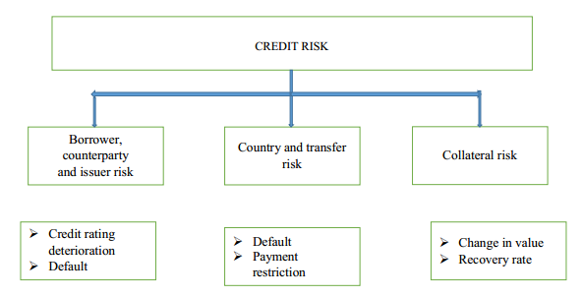

**Figure 1: Losses with credit risks**

(Source: Motocu, 2014, p. 109)

## Measurement of credit risk

## Some the techniques for quantifying the credit risk are given below:

* Two types of credit-risk measuring methods are evident, being qualitative and quantitative. For example, evaluation of borrower-specific factors (total current balances, annual income, employment strengths) helps in detecting possibilities of credit-risks (Namvar et al. 2018, p. 6). In addition to that, quantification of loss overstated default (LGD), and likelihood of failure (PD) and the scope of vulnerability if default occurs are essential factors which influence to reckon the forecasted loss arising due to non-payment of obligation. Further, estimation of credit-scores of borrowers is a quantitative method, which includes credit cycle and credit delinquency-estimates for forecasting probability of future risks (Leo, Sharma & Maddulety, 2019, pp. 3-9).
* ANZ Bank reported that it includes climate-risk assessment as a qualitative factor for estimation of risks. It also considered customer-transition plans for supporting standard lending decision-analytics, quantitatively (ANZ Bank 2019, p. 49). However, Westpac considers location, loan-quality, and tenancy profile of borrowers and nature of loans to estimate credit loss for individuals. In case of corporate and business loans, Westpac focuses on financial risk-ratios (interest-coverage, balance sheets, and debt-serviceability) for estimation of risks (Westpac 2019, p. 114).

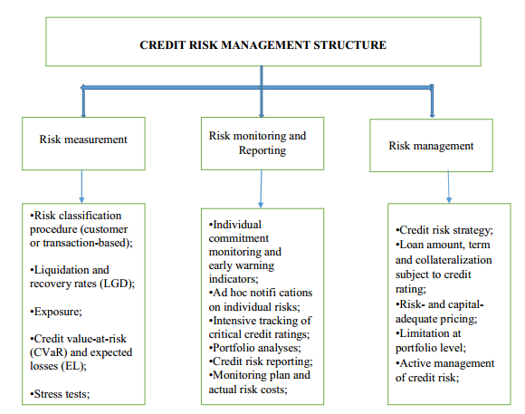

**Figure 2: Credit-risk management strategies**

(Source: Motocu, 2014, p. 111)

* Computation of Cox Proportional Hazard model provides measure of hazard rate, which is a powerful indicator of credit risk (Chernova & Kukush, 2018, p. 37). When economic downturn prevails in the market, percentages of loan recovered is low whereas, probability of failure to repayment rises (Bruche & Aguado 2010, p. 754). [refer to appendix 5]
* Credit-risk rating systems are there, which includes several international standards for risk-assessment, economic behaviours, specificity, and risk appetite of customers (Konovalova, Kristovska & Kudinska, 2016, p. 98). Westpac's approach is similar in this case. It has a credit-risk rating system (considering quality of assets, collaterals involved and credit-risk concentrations), scrutinized by BRCC and CREDCO annually (Westpac 2019, pp. 212-213).
* Market-to-market approach of credit claims include continuous models for risk-measurement by evaluating environment-conditions, historical data of client and current economic relationships with bank (Spuchľáková, Valašková & Adamko, 2015, p. 676). ANZ Bank follows this policy, as it estimates risks associated with external environment factors (climate factors, legal factors), which could enhance chances of default (ANZ 2019, p. 46).
* From Appendix 1, it can be clearly stated that the overall credit exposure of ANZ bank has been increased from $1063772 million in 2107 to $1209364 million in 2019. Hence it can be interpreted that ANZ bank is more vulnerable to defaults.
* The value of the bank when a loan is defaulted is called as Exposure at Default. Post of the Global Financial Crises of 2007-08, banks have adopted specific regulations and guidelines to reduce the exposure at default. The main outcome of Basel Committee is to increase and improve the ability of banks at the time of financial crises. In the recent years, ANZ bank has increased its exposure at default from $899 million in 2017 to $977 million in 2019, and this shows the ANZ bank’s riskiness (Appendix 4).

# Risk control

* Credit risk monitoring at client-level (by identifying repayment disciplines, turnovers, profit margins and good credit-score ratings) and bank-portfolio level (types of credits, mortgages, and diversification of investments and economic position of credit borrowers) are mentionable as risk-controlling measure (Spuchľáková, Valašková & Adamko, 2015, pp. 678-679). Some steps to weaken the ‘Credit risk’ are discussed in Appendix 6.
* Hedging techniques are useful measures of credit-risk management. Risk sharing, transfer and diversification processes within applied limits are some successful hedging strategies (Spuchľáková, Valašková & Adamko, 2015, p. 677). However, limits are client-specific, which includes turnover, credit ratings and financial situations. ANZ Bank reported general hedge accounting defined by AASB9 for managing financial risks (ANZ 2019, p. 109).
* Credit rationing is essential for managing credit risks in future banking environment. It restricts the upper-limits of credit exposure among loan-applicants, despite their abilities to repay them at accelerated interest rates (Jin & Zhang, 2019, p.1).
* Incorporation of credit-policies, risk models and credit scoring (by Migration analysis) and monitoring are essential. In addition to that, RAROC-model for evaluating profitability is essential for credit-exposures. Further, credit insurances, risk-based pricing and covenant reporting over the indenture are some of the established measures of risk-management (Singh, 2014, pp. 49-50).
* Including collaterals against credits are evident in Westpac, which are mortgages, deposits, derivative protections, and loan guarantees (Westpac 2019, p. 215).
* Unexpected loss-measurement by implementing Altman-Z-Score models is essential to assign bond-ratings based on expected losses over fixed duration (Altman & Saunders, 1997, p. 1736). In practice, Westpac undertakes scrutiny-measures for evaluating unexpected losses to establish better self-controls, as per APRA framework (Westpac 2019, p. 111).
* ANZ Bank reported use of Machine Learning to improve risk-controlling and processing activities (ANZ 2019, p. 80).
* ANZ bank has specific Risk management committee which assess the different risks including credit risk and assist the Board of Directors and provide oversight and implementation of ANZ’s the risk management framework providing ANZ’s current and future risk position.
* APRA has approved ANZ bank to use Advanced Internal Ratings (AIRB) based approach to ascertain credit risk. All the credit exposures relating to on and off-balance sheet exposures, committed and contingent exposures and expected losses can be ascertained through AISB.
* The ANZ bank is equipped with Risk Management Framework and it provides specific guidelines while providing loans and advances. Loans with higher value are required to be processed through dual approval process and usage of rating tools (ANZ 2004, p 16).
* The ANZ Risk Management Framework helps in managing credit risk and consists of credit principles and policies. These credit policies provide guidelines to the bank specific to credit cycle.
* ANZ bank has a separate relationship teams which independently assess the risks involved in providing loans and advances. ANZ bank uses services of credit agencies as rating tools and uses KMV portfolio management tool as early warning indicator.
* ANZ has limited the credit lending limits to a single customer with-in the portfolio.
* ANZ bank diversifies its credit risk exposure also through portfolio caps.
* ANZ Bank uses credit policies and scorecards tool in retail lending. Scorecards helps in achieving appropriate risk-return trade-off.

# Impact of COVID-19 on the credit risk of ANZ bank:

According to Business News Australia (2020), ANZ bank’s half year profit has charged by coronavirus and bank announces $1.7 billion impairment cost. It includes $1.3 billion to increase covid-19 cash reserve, Asian investments was impaired by $825 million because those markets are largely affected by COVID-19

According to ANZ bank (2020, p. 29) Covid-19’s influence and length on world economy and respond of governments, businesses and consumers is indeterminate. The half of the year has charged by the Expected Credit Loss (ECL) and provision of ECL as of 31st March 2020 are built on judgement of management by considering Covid-19 influence on the credit exposure of group. Assembled opinions and assumptions by the management are depended on internal and external info and experiences of group according to the performance portfolio during previous worse circumstances.

Credit impairment charge (release): Collectively Assessed

(Source: ANZ bank 2020, p. 29)

Individually Assessed



Total: (collectively and individually):(Source: ANZ bank 2020, p. 29)

## Collectively assessed credit impairment charge:

* March 2020 v March 2019
* Credit impairment cost which is collectively assessed rise by $1035 million. It includes $479, $392, and $149 million increase in the Australia Retail and Commercial, Institutional and New Zealand division. Similarly, March 2020 v September 2019 the impairment of credit increased by $1044 million due to increment of Australia Retail and Commercial by $564 million and Institutional and New Zealand division increase by $336 and $127 million. Divisions are increased by economic material deterioration due to covid-19 pandemic (ANZ bank, 2020, p. 30)

## Individually assessed credit impairment charge:

* March 2020 v March 2019:
* Individually assessed credit impairment cost has increased by $246 million because of a small number of new single name impairments in the institutional division. Similarly, in March 2020 v Sept 2019, the credit impairment of individual assessed became greater by $228 million because a new impairment added in the institutional division (ANZ bank, 2020, p. 30)

## Has the bank applied new strategy to mitigate possible credit risks?

ANZ bank has applied varies methods as a COVID-19 impact response. It provides supportive strategies for lenders, personal home loan consumer and small business loans.

## Customer measure:

* Reduce variable interest lending rates by between 40% and 50%p.a. for customers who have home loans and for small business consumers by 50%pa. Moreover, it announces low fixed rate loans for homeowners and business clients (Response to Covid-19 pandemic, 2020, p. 2)
* On 20 March 2020, bank publish main support on COVID-19 pandemic for personal home loan and small business loan, it includes six-month deferrals for loan repayments (Response to Covid-19 pandemic, 2020, p. 2)
* For owner occupiers two-year fixed rate of 2.19% introduced by ANZ bank. ANZ has established a two-year fixed rate of 2.19%p.a. for it is for owner occupiers who pays principal and interest- it is bank’s lowest fixed rate home loan according to records

ANZ was publicize it on 20 March 2020 (Response to Covid-19 pandemic, 2020, p. 4)

## Personal customer support

* Six-month deferral on repayment of home loan. Request for loan repayment deferral for up to six months with three months review can come from customers. Repayments do not require under home loan repayment deferral until a period. During the period unpaid interest is capitalized which means it includes to the customer’s outstanding loan balance. The measure was publicized as an ANZ’s COVID-19 support part on 20 March 2020 (Response to Covid-19 pandemic, 2020, p. 5)
* Support for personal loan customer. Support request can be come for personal loan consumer which contains payment deferral and loan waiving administration cost for maximum six months with three months review. The bank creates an available option to manage personal loans, containing minimum repayment reduction and redraw funds facility (Response to Covid-19 pandemic, 2020, p. 5)

# Measures ANZ bank has taken to reduce credit risk and their impact.

ANZ bank has had to adopt new and existing credit risk reduction measures to increase risk appetite and tolerance but at the same time incorporate the banks clientele. This section seeks to point out the strengths and weaknesses of the adopted models. The following are some of these models:

* ANZ bank is offering clients an opportunity to defer their loan repayments to up to 6 months to allow businesses enough disposable income to help them survive these tough times. ANZ bank is also extending home loan repayment deadlines to up to 4 months (ANZ Bank Covid-19 Response 2020). This aims to give struggling businesses more time to generate income for interest repayment. This will possibly reduce the risk of default but at the same time reduce the bank’s income thus a loss to the bank.

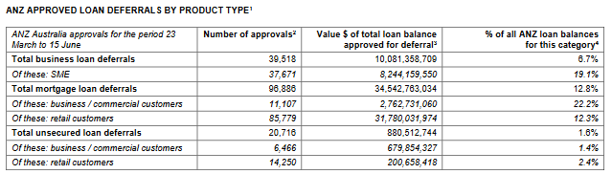

Source: ANZ Bank Covid-19 Response 2020, page 1

* ANZ has issued interest rate discounts on eligible loans of up to 0.25% per annum (ANZ Bank Covid-19 Response 2020). This will give more time to businesses to generate income that will reduce default risk of loans. This has the potential of increasing the bank’s market share in the long run but at the same time reduce the bank’s income.
* ANZ is offering fee waivers on eligible loans on some processing fees such as loan approval fee, valuation administration fee, renegotiation fees, among others. This seeks to reduce risk of loan defaults as well as encouraging the taking up of new loans. However, the issue of such waivers cumulatively reduces the bank’s profitability.
* ANZ has introduced loan top-ups for businesses facing financial hardships subject to credit approval. This strategy works both ways as clients get extra funds and it serves as an extra income stream for the bank. This with help thicken the bank’s cushion on credit risk. It however leads to greater credit risk in the long run.
* ANZ has introduced a split home loan where clients can split their home loan into fixed rate home loan and a variable rate home loan. This will reduce the probability of default in home loans by increasing its diversification. It at the same time reduces the bank’s income.
* ANZ bank has improved consultation between itself and its clients by introducing credit specialists who will better assists its clients in making informed financial decisions during these unpredictable times. This will help the bank reduce the defaults and decrease credit risk by gaining more information about its clients thus better refining its credit analysis. It is however expensive to the bank as it introduces cost.
* For clients who were ahead on their repayments in certain credits; ANZ is offering the option to redraw the extra payment to service any other repayment that are pending. This will reduce credit risk of the clients who have other outstanding loans but at the same time reduce the bank’s excess funds.

# Recommendations for further credit risk reduction.

From the above measures, it is only fair to applaud the management for the swift actions to put in place new plans of action as well as engaging existing ones. However, there is more that can be done to better cover the bank in terms of credit risk. Some of these include:

1. Management should be more involved in decision making of credit facility issuance. The involvement of more stakeholders increases the bank’s confidence in the issue of loans.
2. ANZ bank should seek to better diversify its credit risk i.e. introducing an industry-based bias. This can be achieved by better emphasis on credit facilities to industries least affected by the Covid-19 pandemic. This will reduce the bank’s exposure to a dominos effect of credit default.
3. ANZ bank should use current information in credit analysis instead pre Covid-19 information and trends. This will improve the quality of credit approval through realistic interpretation of client risk of default thus reducing risk.
4. ANZ can choose to transfer the credit risk to credit brokers. Clients can transfer their loans to brokers to reduce its overall credit risk. (Carter, 2020)
5. The bank can offer a repayment holiday for credit facilities facing default. Although it is a risky decision, it will greatly reduce the burden on the clients which will in turn increase its market base in the long run (Atashi, Ilott & Reid, 2020)

# Conclusion

The report demonstrated that credit risk management is essential to save financial institutions from bankruptcy. In this case, credit-risk identification, qualitative and quantitative estimation, and supportive management policies are necessary techniques. Coronavirus influences the ANZ’s profit as a huge amount from equity bank invests for impairment charge and investment loss. Bank has offered several opportunities for credit holders. It extends the repayment period and cut the variable interest lending rates. All these facilities may cause detrimental effect on bank’s economic position. ANZ has made several bold steps towards reducing credit risk but at the same time keeping a keen eye on its client base. It has tried to reduce credit risk but at the same time factor in its client’s economic position. The bank has offered loan deferral, interest rate discounting, fee waivers, loan top-ups, split loans, enhanced consultation among other measures. However, there is room for: management involvement in credit issuing, diversification of loans, striving to get more government grants, use of pre Covid-19 data among many more possible measures.

# Reference list

Altman, EI & Saunders, A 1997, ‘Credit risk measurement: Developments over the last 20 years’, *Journal of banking & finance*, vol. 21, no. 11-12, pp. 1721-1742.

ANZ 2019, ANZ *2019 Annual Report*, viewed 10 October 2020, <<https://www.anz.com/content/dam/anzcom/shareholder/ANZ-2019-Annual-Report.pdf>>.

ANZ 2019, *Full Year Results Presentation & Investor Discussion Pack,* viewed 10 October 2020, < <https://www.anz.com/content/dam/anzcom/shareholder/ANZ-2019-Full-Year-Results-Investor-Discussion-Pack-%26-IDP.pdf>>.

ANZ 2018, ANZ *2018 Annual Report*, viewed 10 October 2020, <<https://www.anz.com/content/dam/anzcom/shareholder/anz_2018_annual_report_final.pdf>>.

ANZ 2004, *The ANZ Risk Management Framework*, viewed 10 October 2020

<<https://www.anz.com/documents/au/investor/ANZRiskManagementFramework.pdf>>

ANZ Bank Covid-19 Response 2020, *Response to COVID-19 Pandemic,* viewed 3 October 2020

<https://www.anz.com/content/dam/anzcom/shareholder/ANZ-Covid-19-response-30%20April-2020.pdf>

ANZ Bank 2020, *ANZ Half Year Consolidated Financial Report Dividend Announcement and Appendix 4D,* viewed 9 October 2020

file:///C:/Users/User/Downloads/2020-Half-Year-Results-Dividend-Announcement-&-Appendix-4D.pdf

ANZ Bank Covid-19 Response 2020, Response to Covid-19 Pandemic, Viewed 3 October 2020

<https://www.anz.com/content/dam/anzcom/shareholder/June-2020-ANZ-COVID-19-measures-(update-to-the-House-of-Representatives-Standing-Committee-on-Economics).pdf>

Amy Atashi, Michael Ilott & Kim Reid; Retail banking and responsible lending during COVID-19, 1 June 2020

(<https://www.allens.com.au/insights-news/insights/2020/04/retail-banking-and-responsible-lending-during-covid-19/>)

Bruche, M & González-Aguado, C 2010, ‘Recovery rates, default probabilities, and the credit cycle’, *Journal of Banking and Finance*, vol. 34, no. 4, pp. 754–764.

Business News Australia 2020, *ANZ profit dives on $1.7 billion impairment charge*, viewed 29 September 2020,<<https://www.businessnewsaus.com.au/articles/anz-profit-dives-on--1-7-billion-impairment-charge.html>>

Chernova, O & Kukush, A 2018, ‘Confidence regions in Cox proportional hazards model with measurement errors and unbounded parameter set’ *Modern Stochastics: Theory and Applications,* vol. 5, no. 1, pp. 37-52, viewed 8th October 2020, <[https://arxiv.org/pdf/1804.01674.pdf](https://arxiv.org/pdf/1804.01674.pdf%20) >.

Hull, JC 2018, *Risk Management and Financial Institution,* 5th edn,John Wiley & Sons, Inc, Hoboken, New Jersey.

Jin, Y & Zhang, S 2019, ‘Credit rationing in small and micro enterprises: A theoretical analysis’, *Sustainability*, vol. 11, no. 5, pp. 1-15, viewed 8th October 2020, <<https://www.mdpi.com/2071-1050/11/5/1330/htm>>.

Konovalova, N, Kristovska, I & Kudinska, M 2016, ‘Credit risk management in commercial banks’, *Polish Journal of Management Studies*, vol. 13, no. 2, pp. 90-100, viewed 8th October 2020, <[https://www.researchgate.net/publication/304669880_Credit_risk_management_in_commercial_banks](https://www.researchgate.net/publication/304669880_Credit_risk_management_in_commercial_banks%20) >.

Leo, M, Sharma, S & Maddulety, K 2019, ‘Machine learning in banking risk management: A literature review’, *Risks*, vol. 7, no. 29, pp. 1-22. viewed 8th October 2020, <<https://www.mdpi.com/2227-9091/7/1/29/htm>>.

Motocu, M 2014, ‘Monitoring Credit Exposures At Risk’. *Quality-Access to Success*, vol. 15, no. 3, pp. 108-113.

Melanie Carter, 7 ways to manage credit risk and safeguard your global trade growth, 21/10/2020  
<<http://www.tradeready.ca/2014/trade-takeaways/7-ways-manage-credit-risks-safeguard-global-trade-growth/>>

Namvar, A, Siami, M, Rabhi, F & Naderpour, M 2018, ‘Credit risk prediction in an imbalanced social lending environment’, viewed at 7th October 2020 <[https://www.researchgate.net/publication/325407031_Credit_risk_prediction_in_an_imbalanced_social_lending_environment](https://www.researchgate.net/publication/325407031_Credit_risk_prediction_in_an_imbalanced_social_lending_environment%20) >.

Singh, A 2014, ‘Operational risk management in Indian commercial banks’, *International Journal of Marketing, Financial Services & Management Research*, vol. 4, no. 2, pp.47-51, viewed 8th October 2020, <<http://www.indianresearchjournals.com/pdf/IJMFSMR/2013/July/6.pdf>>.

Spuchľáková, E, Valašková, K & Adamko, P 2015, ‘The credit risk and its measurement, hedging and monitoring’, *Procedia Economics and Finance*, vol. 24, pp. 675-681.

Verizon Media 2020*, Australia and New Zealand Banking Group Limited (ANZ.AX),* viewed 10 October 2020, <<https://au.finance.yahoo.com/quote/ANZ.AX/history?period1=1530403200&period2=1561852800&interval=1wk&filter=history&frequency=1wk&includeAdjustedClose=true>>.

Westpac 2019, *Westpac 2019 Annual Report*, viewed 10 October 2020, <<https://www.westpac.com.au/content/dam/public/wbc/documents/pdf/aw/ic/2019_Westpac_Group_Annual_Report.pdf>>.

# Appendix

1. **Credit Risk Exposure**



(Source: ANZ 2019, p. 158; ANZ 2018, p. 116)

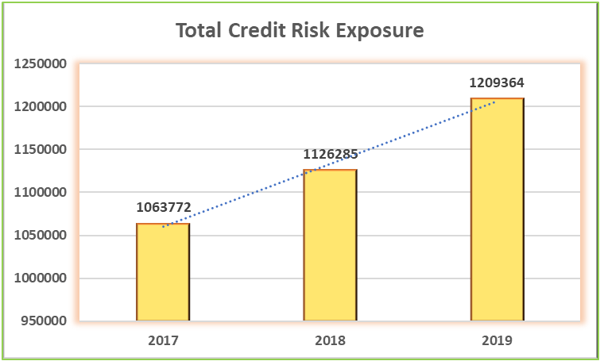

**Interpretation:** ANZ banks vulnerability towards credit risk is increasing as the amount of centration in the pool consists of various financial assets which are subject to default is rising (ANZ 2018, p. 116).

1. **Credit Impairment Charge**



(Source: ANZ 2019, p. 102; ANZ 2018, p. 72)

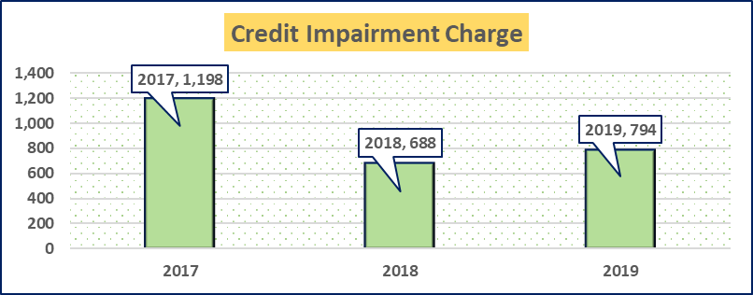

**Interpretation:** Credit impairment Charges slightly raised from the year 2018 to 2019 as financial health of overall Australian economy became worsen (ANZ 2019, p. 60). In contrast, during the year 2018, due to improvement in the recovery of individual and credit card loan impairment cost reduced (ANZ 2018, p. 22).

1. **Altman’s Z-score Model**(Source: ANZ 2019, pp. 63-177; Verizon Media 2020)

**Interpretation:** Z value is well under 1.81, so ANZ is facing high chances of bankruptcy (Hull 2019, p. 433).

1. **Exposure at default**



(Sources: ANZ 2019)

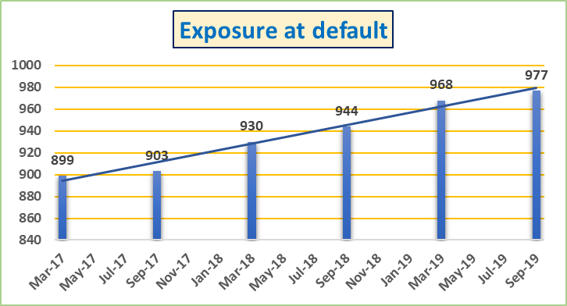

**Interpretation**: It is quite evident from the chart that the figures of EAD showed an increasing trend during the last three years. It indicates the riskiness of ANZ’s corporate profile.

1. **Default and Recovery Rates**



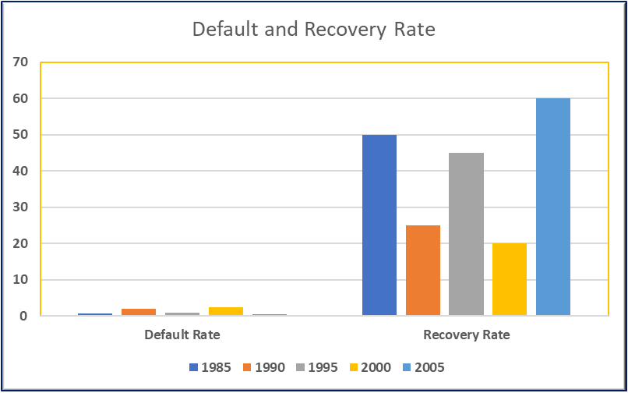

(Adapted From: Bruche & Aguado 2010, p. 755)

**Interpretation:** Indirect relationship holds between non-remittance and retrieval rate of borrowing amount. This happens due to the ‘business cycle’ phenomenon (Bruche & Aguado 2010, p. 754).



**Recognize the variables that influence the risks**

**Examine the expected outcomes**

**Oversee the policies taken to restrain ‘Default Risk’**

**Develop a master plan to dimmish the level of uncertainties.**

(Adapted From: Konovalova, Kristovska & Kudinska, 2016, p. 97)

1. **Assessment:** 
   1. **Individually:**

When one of impaired loans and advance have crossed the doorstep and ANZ bank has explored an impairment event then the bank assesses the need for a provision individually (ANZ Bank, 2019, p. 144)

* 1. **Collectively**:

When small value loans and advances losses might have been experienced but still unidentified and some individual loans and advances that bank does not assessed as impaired then the institution assesses them collectively as assets pool (ANZ Bank2019, p. 144)

1. **Impairment:**
2. **Individually**: Impaired loans and advances are assessed and ANZ has evidence that it may not collect the principal and interest (ANZ Bank 2019, p. 144)
3. **Collectively**: ANZ creates an estimated provision on basis previous years’ loss events for assets which have same credit risk characteristic to others in the collective pool. The bank uses current observable data (e.g. changing economic situation) to adjust the historical loss experience (ANZ Bank 2019, p. 144)